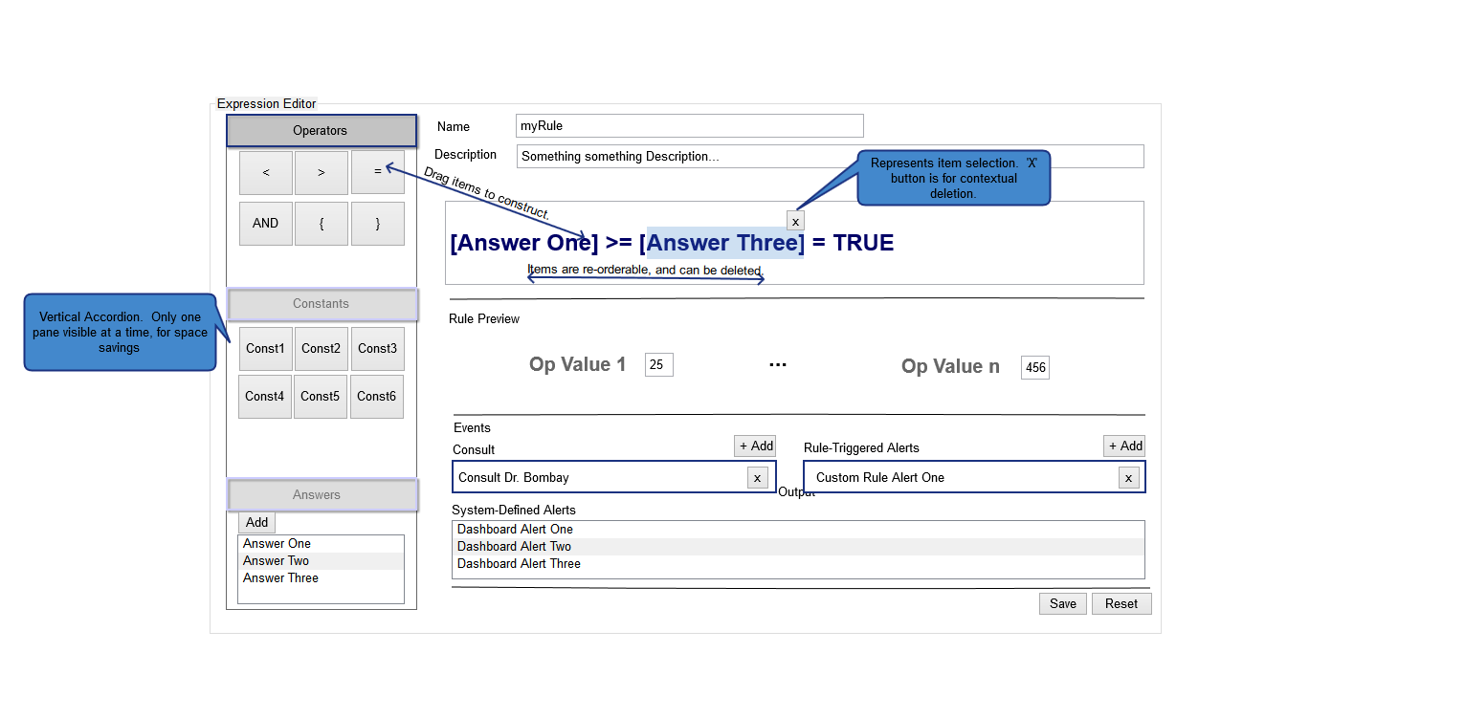

Figure 1: Rule/Event Expression Editor

* Allows building a Rule or Event via drag and drop operation, from known comparison operators, defined Constants, and Answers. The expression is viewable as it is being built, context-editable, and elements can be deleted/reordered.
* Events can be added/edited and mapped to the Rule.
* This view is accessible via main navigation, and via Add Rule in-context with Answers, for editable cases.

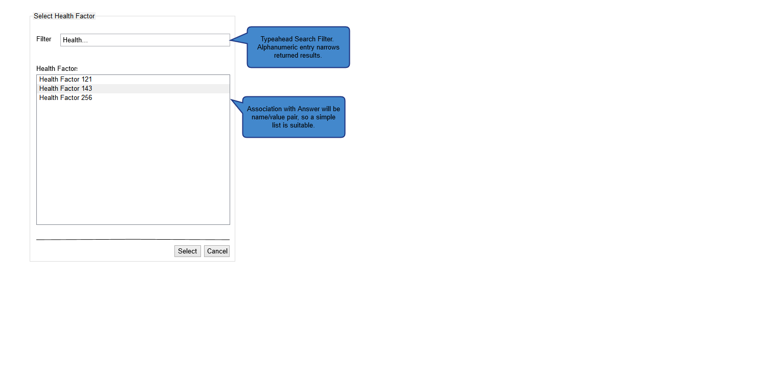

Figure 2: Select Health Factor

* Health Factors are pre-defined (system), but can be assigned. This view lists the Health Factors assignable, with a typeahead filter for long lists, and paging controls as necessary.

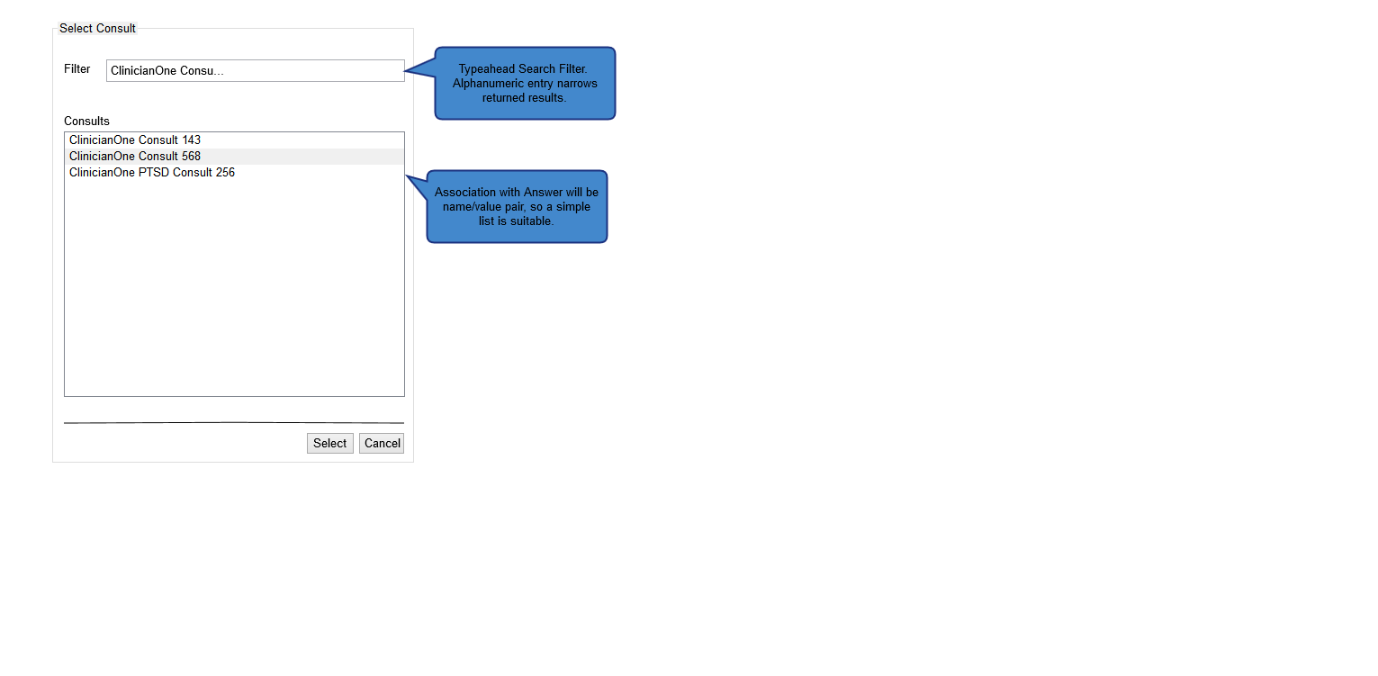

Figure 3: Select Consult View

* Consults are pre-defined (system), but can be selected and assigned. This view lists assignable Consults, with filtration of the list provided by typeahead search on Name. In Editors, this will be simple name/value pairing.

